INDEX

1.INTRODUCTION------------------------------------------------------ 2-3

2. ANALYSIS (Details about below side headings)
2.1 problem definition---------------------------------------------------11-12
2.2 Proposed solution----------------------------------------------------12
2.3 Feasibility study
2.3.1 Operational Feasibility---------------------------------------13
2.3.2 Technical Feasibility------------------------------------------13
2.3.3 Economical Feasibility----------------------------------------14
2.4 Software Requirement Specification----------------------------14

3. DESIGN
3.1 Unified Modeling Language
3.1.1 Use case Diagram------------------------------------------------15
3.1.2 Class diagram-----------------------------------------------------16
3.1.3 Sequence Diagram---------------------------------------------- 17
3.1.4 Collabration Diagram-------------------------------------------18
3.1.5 Activity Diagram--------------------------------------------------20
DFD

4. CODING(only algorithm) -----------------------------------------------23-42

6. TESTING ----------------------------------------------------------------------43-48

7. OUTPUT SCREENS --------------------------------------------------------49-54

8. CONCLUSION ---------------------------------------------------------------55-56

9. BIBLIOGRAPHY ------------------------------------------------------------57-58
10.Annexure—java material/android /.net (3-5pages) UML, DFD,all materials here

INTRODUCTION

1. INTRODUCTION

Job seekers - Job seeker, who is searching for job can enter the website, they can register and build their resume for free of cost.
User- The employer can enter the website and create their own account for free of cost.they can post job and search employee database.
Admin- The full control over the users and their functions.

Career Info Application was developed for creating an interactive job vacancy form of candidates.This web application is to be conceived in its current form as a dynamic site requiring constant updates both from the seekers as well as companies.

An employeer being registered in the website has the facility to buy the services.Being an authorized user he can publish vacancy details, either of CSE or functional of the organisation.

A job seeker being registered in the website has the provision to fill up the curriculum vitae and in further he/she could update the resume.Based upon the candidate profile the Career Info
Segregates candidates and post their resume to the corresponding companies.The candidates are intimated, with the list of companies they are listed in, in their respective home page.The company has the provision of receiving candidate resumes.

A user is checked for authentication by user name and password.

The database is perfectly designed sticking to the rules Data Consistency, Data Dependency, Non Redundancy and Data Integrity.

Literature Survey

2. Literature Survey

2.1 Theoretical Background

The Theoretical background of the “NYMBLE” mainly used to know how to get interacted with the USER and to know the updates and to obtain the solutions to our problems.

2.2 Technical Background:

JSP:

Java server Pages is a simple, yet powerful technology for creating and maintaining dynamic-content web pages. Based on the Java programming language, Java Server Pages offers proven portability, open standards, and mature re-usable component model .The Java Server Pages architecture enables the separation of content generation from content presentation. This separation not eases maintenance headaches; it also allows web team members to focus on their areas of expertise. Now, web page designer can concentrate on layout, and web application designers on programming, with minimal concern about impacting each other’s work.

Features of JSP

Portability:

Java Server Pages files can be run on any web server or web-enabled application server that provides support for them. Dubbed the JSP engine, this support involves recognition, translation, and management of the Java Server Page lifecycle and its interaction components.

Components

It was mentioned earlier that the Java Server Pages architecture can include reusable Java components. The architecture also allows for the embedding of a scripting language directly into the Java Server Pages file. The components current supported include Java Beans, and Servlets.

Processing

A Java Server Pages file is essentially an HTML document with JSP scripting or tags. The Java Server Pages file has a JSP extension to the server as a Java Server Pages file. Before the page is served, the Java Server Pages syntax is parsed and processed into a Servlet on the server side. The Servlet that is generated outputs real content in straight HTML for responding to the client.

Access Models:

A Java Server Pages file may be accessed in at least two different ways. A client’s request comes directly into a Java Server Page. In this scenario, suppose the page accesses reusable Java Bean components that perform particular well-defined computations like accessing a database. The result of the Beans computations, called result sets is stored within the Bean as properties. The page uses such Beans to generate dynamic content and present it back to the client.
In both of the above cases, the page could also contain any valid Java code. Java Server Pages architecture encourages separation of content from presentation.

HTML:

HTML, an initialism of Hypertext Markup Language, is the predominant markup language for web pages. It provides a means to describe the structure of text-based information in a document by denoting certain text as headings, paragraphs, lists, and so on and to supplement that text with interactive forms, embedded images, and other objects. HTML is written in the form of labels (known as tags), surrounded by angle brackets. HTML can also describe, to some degree, the appearance and semantics of a document, and can include embedded scripting language code which can affect the behavior of web browsers and other HTML processors.

HTML is also often used to refer to content of the MIME type text/html or even more broadly as a generic term for HTML whether in its XML-descended form (such as XHTML 1.0 and later) or its form descended directly from SGML

Hyper Text Markup Language

Hypertext Markup Language (HTML), the languages of the World Wide Web (WWW), allows users to produces Web pages that include text, graphics and pointer to other Web pages (Hyperlinks).
HTML is not a programming language but it is an application of ISO Standard 8879, SGML (Standard Generalized Markup Language), but specialized to hypertext and adapted to the Web. The idea behind Hypertext is that instead of reading text in rigid linear structure, we can easily jump from one point to another point. We can navigate through the information based on our interest and preference. A markup language is simply a series of elements, each delimited with special characters that define how text or other items enclosed within the elements should be displayed. Hyperlinks are underlined or emphasized works that load to other documents or some portions of the same document.
HTML can be used to display any type of document on the host computer, which can be geographically at a different location. It is a versatile language and can be used on any platform or desktop.
HTML provides tags (special codes) to make the document look attractive. HTML tags are not case-sensitive. Using graphics, fonts, different sizes, color, etc., can enhance the presentation of the document. Anything that is not a tag is part of the document itself.
Basic HTML Tags:
<! -- --> specifies comments
<A>……….</A> Creates hypertext links
<B>……….</B> Formats text as bold
<BIG>……….</BIG> Formats text in large font.
<BODY>…</BODY> Contains all tags and text in the HTML document
<CENTER>...</CENTER> Creates text
<DD>…</DD> Definition of a term
<DL>...</DL> Creates definition list
<FONT>…</FONT> Formats text with a particular font
<FORM>...</FORM> Encloses a fill-out form
<FRAME>...</FRAME> Defines a particular frame in a set of frames
<H#>…</H#> Creates headings of different levels( 1 – 6 )
<HEAD>...</HEAD> Contains tags that specify information about a document
<HR>...</HR> Creates a horizontal rule
<HTML>…</HTML> Contains all other HTML tags
<META>...</META> Provides meta-information about a document
<SCRIPT>…</SCRIPT> Contains client-side or server-side script
<TABLE>…</TABLE> Creates a table
<TD>…</TD> Indicates table data in a table
<TR>…</TR> Designates a table row
<TH>…</TH> Creates a heading in a table

Apache Tomcat

Introduction to Tomcat

Tomcat is the Reference Implementation for the Java Servlet 2.2 and Java Server Pages 1.1 Technologies. It is the official reference implementation for these complementary technologies. Tomcat is a servlets container with a JSP environment. A servlet container is a runtime shell that manages and invokes servlets on behalf of users. Developed under the Apache license in an open and participatory environment,

Tomcat is intended to be a collaboration of the best-of-breed developers from around the world.

Tomcat and Servlets

As mentioned above Tomcat is the reference implementation for the Java Servlet 2.2 technology and obviously conforms to the specification that describes the programming environment that must be provided by all servlet containers that is documented in the Servlet API Specification, Version 2.2. This specification may be downloaded from
This document may be used to understand the web application directory structure and deployment file, methods of mapping request URLs to servlets, container managed security, and the syntax of the web.xml, Web Application Deployment Descriptor.

Installation

Tomcat will operate under any Java Development Kit (JDK) environment that provides a JDK 1.1 or JDK 1.2 compatible platform. The JDK is required so that your servlets, other classes, and JSP pages can be compiled.
Once you have downloaded the required file, unzip it to a directory of your choice. (In the Microsoft Lab 5 at UWI the file is extracted directly to the C drive (C :\)). A sub-directory named Jakarta-tomcat is created and this is the root directory of the tomcat hierarchy.

Tomcat 5.x

Implements the Servlet 2.4 and JSP 2.0 specifications
Reduced garbage collection, improved performance and scalability
Native Windows and UNIX wrappers for platform integration Faster JSP parsing

ANALYSIS

3. Analysis

3.1 problem definition

This project aims at the existing users’ credentials must be updated, making it impractical. Verifier-local revocation (VLR) fixes this shortcoming by requiring the server (“verifier”) to perform only local updates during revocation. Unfortunately, VLR requires heavy computation at the server that is linear in the size of the blacklist.

3.2 Proposed solution

We present a secure system called Nymble, which provides all the following properties: anonymous authentication, backward unlinkability, subjective blacklisting, fast authentication speeds, rate-limited anonymous connections, revocation auditability (where users can verify whether they have been blacklisted), and also addresses the Sybil attack to make its deployment practical In Nymble, users acquire an ordered collection of nymbles, a special type of pseudonym, to connect to websites. Without additional information, these nymbles are computationally hard to link,and hence using the stream of nymbles simulates anonymous access to services.

3.3 Feasibility Study

Feasibility study is an important phase in the software development process. It enables the developer to have an assessment of the product being developed. It refers to the feasibility study of the product in terms of outcomes of the product, operational use and technical support required for implementing it.
Feasibility study should be performed on the basis of various criteria and parameters.

The various feasibility studies are:

Operational feasibility
Technical feasibility
Economic feasibility

3.3.1 Operational Feasibility

The aspect of study is to check the level of acceptance of the system by the user. This includes the process of training the user to use the system efficiently. The user must not feel threatened by the system, instead must accept it as a necessity. The level of acceptance by the users solely depends on the methods that are employed to educate the user about the system and to make him familiar with it. His level of confidence must be raised so that he is also able to make some constructive criticism, which is welcomed, as he is the final user of the system.

3.3.2 Technical Feasibility

This study is carried out to check the technical feasibility, that is, the technical requirements of the system. Any system developed must not have a high demand on the available technical resources. This will lead to high demands on the available technical resources. This will lead to high demands being placed on the client. The developed system must have a modest requirement, as only minimal or null changes are required for implementing this system.

3.3.3 Economic Feasibility

This study is carried out to check the economic impact that the system will have on the organization. The amount of fund that the company can pour into the research and development of the system is limited. The expenditures must be justified. Thus the developed system as well within the budget and this was achieved because most of the technologies used are freely available. Only the customized products had to be purchased.
3.4 Software Requirement Specification

Platform specification

Operating system: Any Operating System after WINDOWS XP
Language:Java1.6
Database: Oracle10g
Server Tomcat Apache6.0.29
Tool: Net beans IDE

Minimal hardware requirements
Processor: 1.0GHZ
RAM: 256MB
HARD DISK: 30G

DESIGN

4.DESIGN

4.1 UNIFIED MODELING LANGUAGE

The Unified Modeling Language (UML) is a Standard language for specifying, visualizing, constructing and documenting the software system and its components. The UML focuses on the conceptual and physical representation of the system. It captures the decisions and understandings about systems that must be constructed.

4.1.1 Use Case Diagram

Use case: Use case diagrams are one of the five diagrams in the UML for modeling the dynamic aspects of the systems (activity diagrams, sequence diagram, state chart diagram, collaboration diagram are the four other kinds of diagrams in the UML for modeling the dynamic aspects of systems).use case diagram are central to modeling the behavior of the system, a sub-system, or a class. Each one shows a set of use cases and actors and relations.
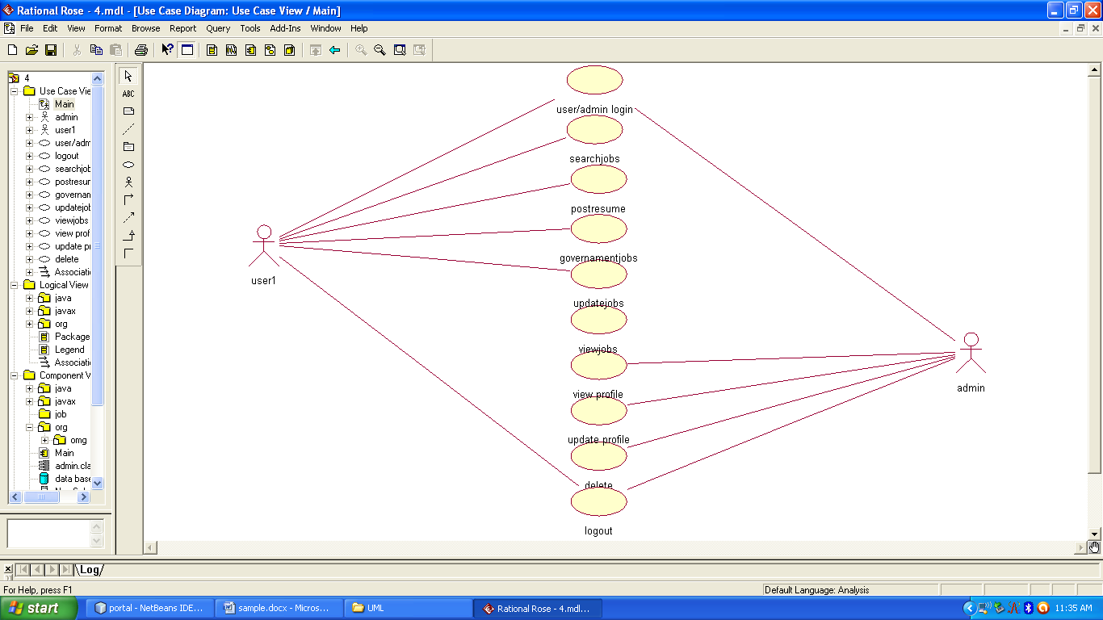

4.1.5 Class Diagram

Def: A “Class Diagram” shows a set of classes, interfaces and collaborations and their relationships. These diagrams are most common diagram in modeling object oriented systems
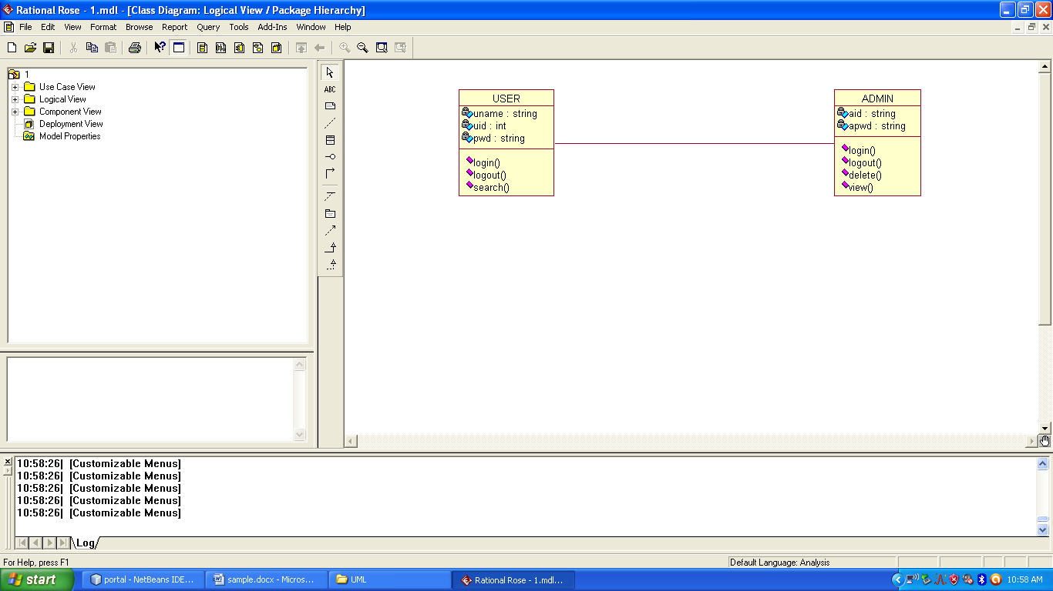

4.1.2 Sequence Diagram
Def: Sequence diagram is an interaction diagram which is focuses on the time ordering of messages. It shows a set of objects and messages exchanged between these objects.This diagram illustrates the dynamic view of a system .

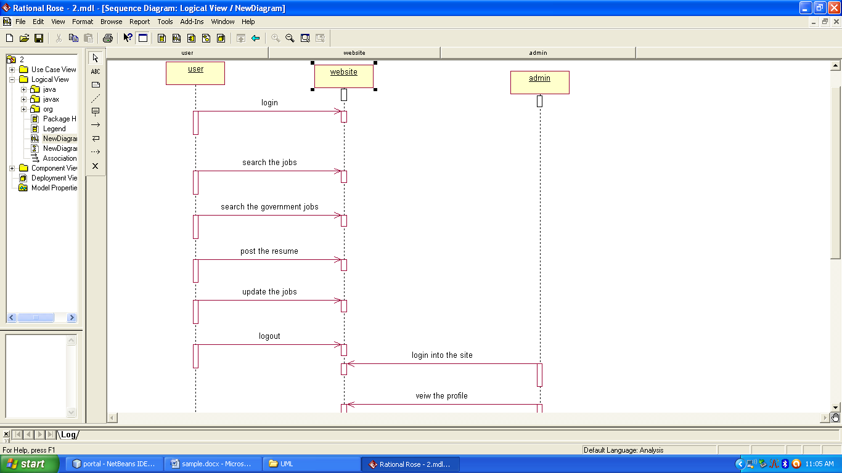

Collabaration diagram
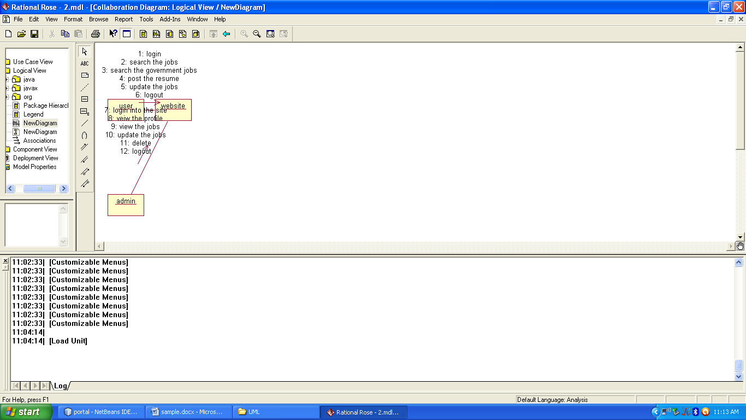

Statechart diagram:

State chart diagram shows the state of actions that can be performed in an event. It shows two modules starting state and ending state.

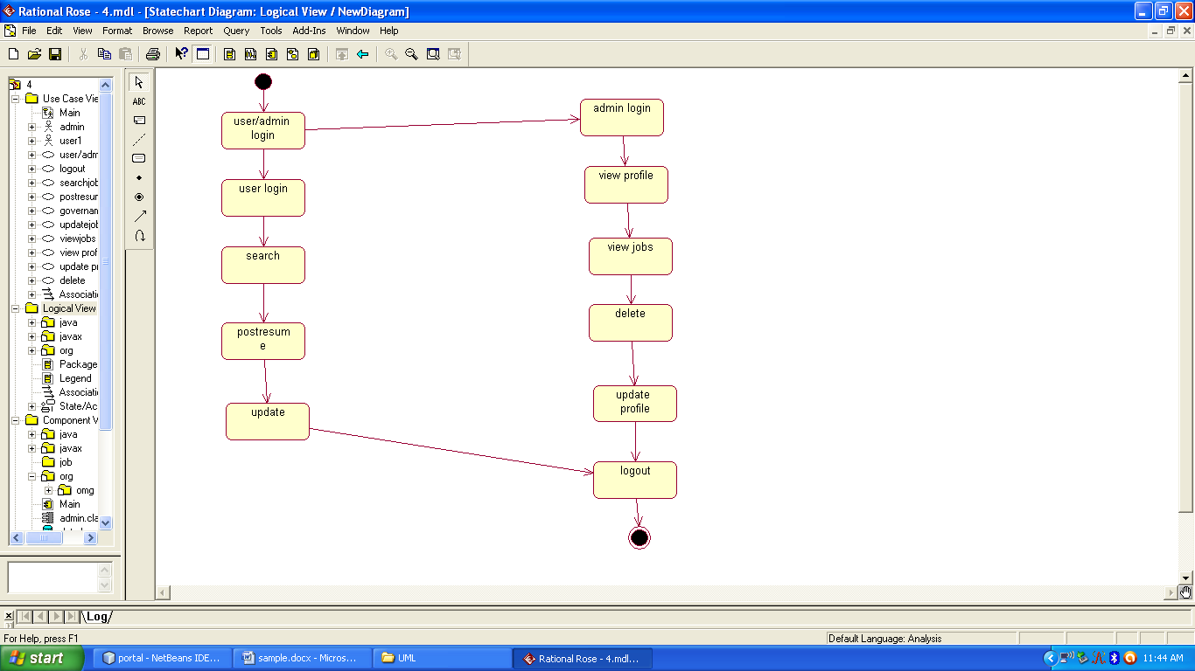

4.1.3 Activity Diagram
Def: An Activity diagram shows the flow from activity to activity within a system it emphasizes the flow of control among objects.

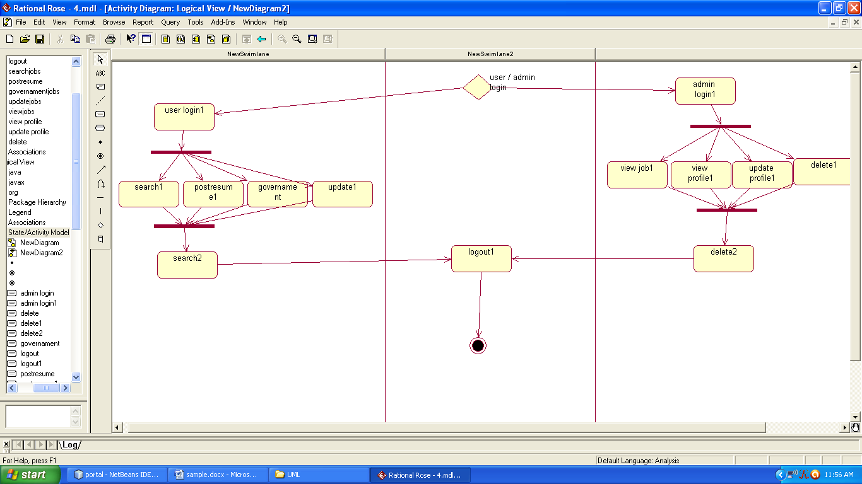

Component Diagram
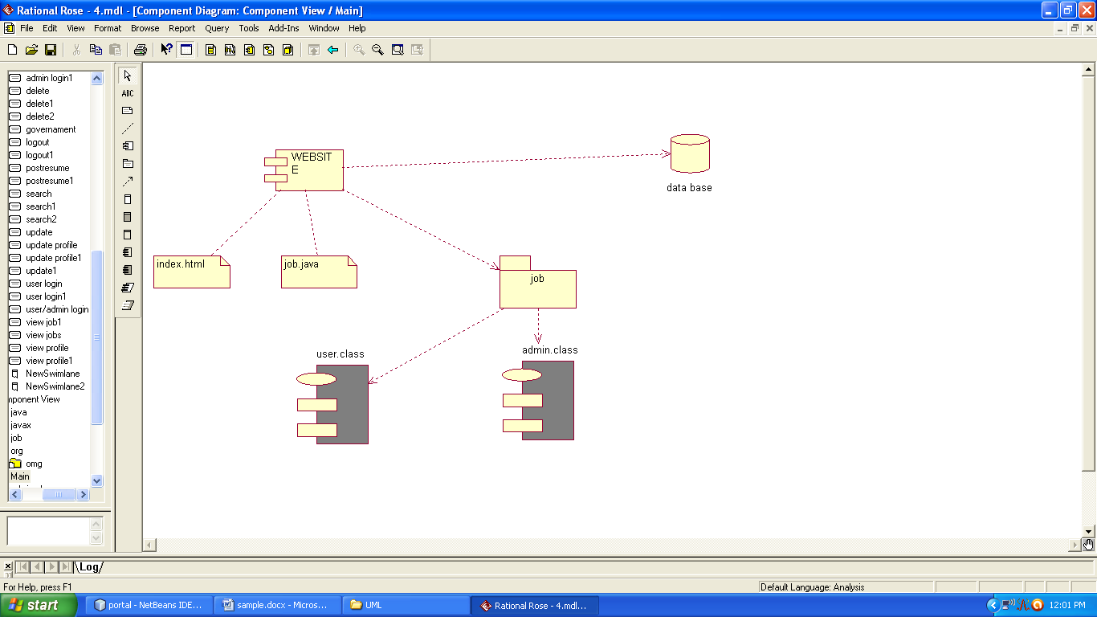

Deployement Diagram
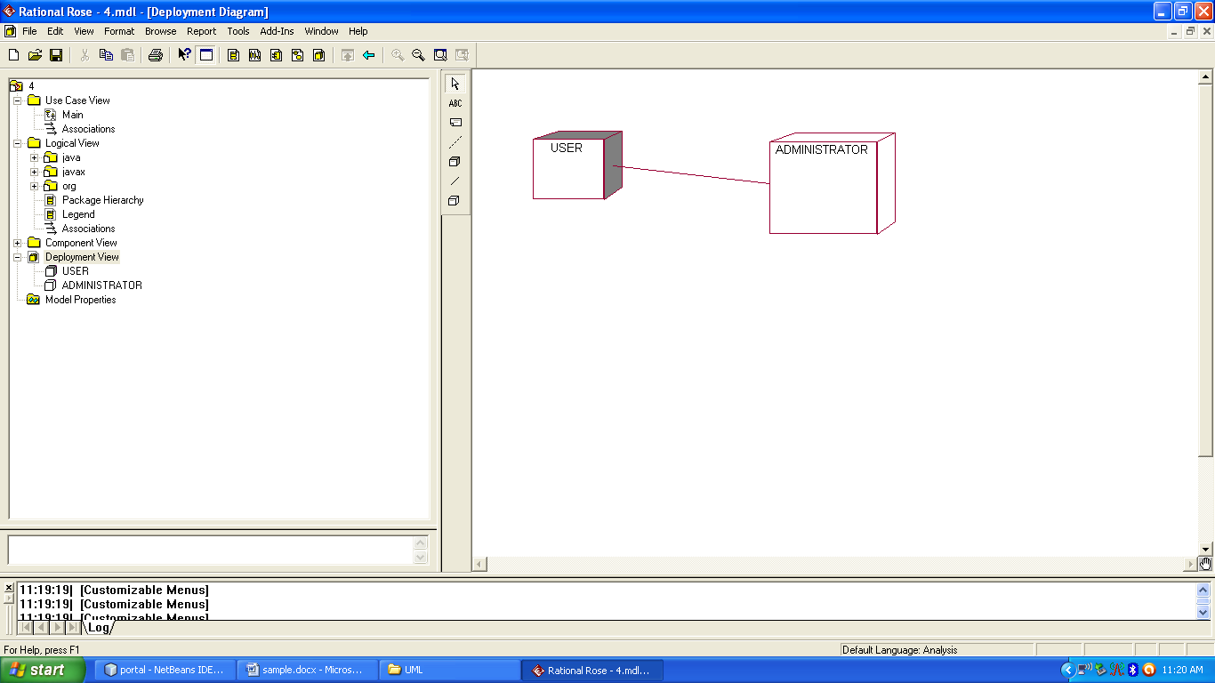

CODING

5. Coding
Home.html
<!DOCTYPE html PUBLIC "-//W3C//DTD XHTML 1.0 Transitional//EN" "http://www.w3.org/TR/xhtml1/DTD/xhtml1-transitional.dtd"[]>
<html xmlns="http://www.w3.org/1999/xhtml" dir="ltr" lang="en-US" xml:lang="en">
<head>
<!--
Created by Artisteer v3.0.0.39952
Base template (without user's data) checked by http://validator.w3.org : "This page is valid XHTML 1.0 Transitional"
-->
<meta http-equiv="Content-Type" content="text/html; charset=UTF-8" />
<title>New Page</title>
<meta name="description" content="Description" />
<meta name="keywords" content="Keywords" />

<link rel="stylesheet" href="style.css" type="text/css" media="screen" />
<!--[if IE 6]><link rel="stylesheet" href="style.ie6.css" type="text/css" media="screen" /><![endif]-->
<!--[if IE 7]><link rel="stylesheet" href="style.ie7.css" type="text/css" media="screen" /><![endif]-->

<script type="text/javascript" src="jquery.js"></script>
<script type="text/javascript" src="script.js"></script>
<script type="text/javascript">
function fun()
{
var a=document.f2.email.value;
var b=document.f2.password.value;

if(a=="")
{
alert("please give email address");
}
else if(b=="")
{
alert("please enter password");
}
else
{
f2.action="loginvalidate.jsp";
f2.submit();
}
}

</script>
</head>
<body>
<div id="art-main">
<div class="art-sheet">
<div class="art-sheet-tl"></div>
<div class="art-sheet-tr"></div>
<div class="art-sheet-bl"></div>
<div class="art-sheet-br"></div>
<div class="art-sheet-tc"></div>
<div class="art-sheet-bc"></div>
<div class="art-sheet-cl"></div>
<div class="art-sheet-cr"></div>
<div class="art-sheet-cc"></div>
<div class="art-sheet-body">
<div class="art-header">
<div class="art-header-clip">
<div class="art-header-png"></div>
<div class="art-header-jpeg"></div>
</div>
<div class="art-headerobject"></div>
<div class="art-logo">
<h1 class="art-logo-name"><a href="./index.html">JOB MANIA*****</a></h1>
<h2 class="art-logo-text">Find a best job for you. </h2>
</div>
</div>
<div class="cleared reset-box"></div>
<div class="art-nav">
<div class="art-nav-l"></div>
<div class="art-nav-r"></div>
<div class="art-nav-outer">
<ul class="art-hmenu">
<li>
<a href="jobmania.jsp"><span class="l"></span><span class="r"></span><span class="t">HOME</span></a>
</li>
<li>
<a href="./search jobs.jsp" class="active"><span class="l"></span><span class="r"></span><span class="t">search jobs</span></a>
</li>
<li>
<a href="./post resume.jsp" class="active"><span class="l"></span><span class="r"></span><span class="t">post resume</span></a>
</li>
<li>
<a href="./job seeker.jsp" class="active"><span class="l"></span><span class="r"></span><span class="t">job seeker</span></a>
</li><br></br>
<li>
<a href="searchalljobs.jsp" class="active"><span class="l"></span><span class="r"></span><span class="t">SEARCH ALL JOBS</span></a>
</li>
<li>
<a href="governament.jsp" class="active"><span class="l"></span><span class="r"></span><span class="t">GOVERNAMENT JOBS</span></a>
</li>

</ul>
</div>
</div>
<div class="cleared reset-box"></div>
<div class="art-content-layout">
<div class="art-content-layout-row">
<div class="art-layout-cell art-content">
<div class="art-post">
<div class="art-post-body">
<div class="art-post-inner art-article">
<div class="art-postmetadataheader">

&nbsp&nbsp&nbsp&nbsp&nbsp&nbsp&nbsp&nbsp&nbsp&nbsp <a href="postresume.jsp">create new account</a><br><br>
&nbsp&nbsp&nbsp&nbsp&nbsp&nbsp&nbsp&nbsp&nbsp&nbsp <a href="update.jsp">Update Profile</a>

<div class="cleared"></div>
</div>
<div class="art-postcontent">
<p>
</div>
<div class="cleared"></div>
</div>

<div class="cleared"></div>
</div>
</div>

<div class="cleared"></div>
</div>
<div class="art-layout-cell art-sidebar1">
<div class="art-login withblock">
<div class="art-login withblock-tl"></div>
<div class="art-login withblock-tr"></div>
<div class="art-login withblock-bl"></div>
<div class="art-login withblock-br"></div>
<div class="art-login withblock-tc"></div>
<div class="art-login withblock-bc"></div>
<div class="art-login withblock-cl"></div>
<div class="art-login withblock-cr"></div>
<div class="art-login withblock-cc"></div>
<div class="art-login withblock-body">
<div class="art-login withblockheader">
<h3 class="t">login with</h3><br></br>
</div>
<div class="art-login withblockcontent">
<div class="art-login withblockcontent-tl"></div>
<div class="art-login withblockcontent-tr"></div>
<div class="art-login withblockcontent-bl"></div>
<div class="art-login withblockcontent-br"></div>
<div class="art-login withblockcontent-tc"></div>
<div class="art-login withblockcontent-bc"></div>
<div class="art-login withblockcontent-cl"></div>
<div class="art-login withblockcontent-cr"></div>
<div class="art-login withblockcontent-cc"></div>
<div class="art-login withblockcontent-body">
<form name="f2">
<ul>

email:<input type="text" name="email"><br><br>
password:<input type="password" name="password"><br></br>

USER:<input type="radio" name="r" value="USER">
ADMIN:<input type="radio" name="r" value="ADMIN"><br></br>
<input type="button" value="login" onclick="return fun()"/>

</ul>
</form>
<div class="cleared"></div>
</div>
</div>
<div class="cleared"></div>
</div>
</div>
<div class="art-block">
<div class="art-block-tl"></div>
<div class="art-block-tr"></div>
<div class="art-block-bl"></div>
<div class="art-block-br"></div>
<div class="art-block-tc"></div>
<div class="art-block-bc"></div>
<div class="art-block-cl"></div>
<div class="art-block-cr"></div>
<div class="art-block-cc"></div>
<div class="art-block-body">

<div class="art-blockheader">

</div>
<div class="art-blockcontent">
<div class="art-blockcontent-tl"></div>
<div class="art-blockcontent-tr"></div>
<div class="art-blockcontent-bl"></div>
<div class="art-blockcontent-br"></div>
<div class="art-blockcontent-tc"></div>
<div class="art-blockcontent-bc"></div>
<div class="art-blockcontent-cl"></div>
<div class="art-blockcontent-cr"></div>
<div class="art-blockcontent-cc"></div>
<div class="art-blockcontent-body">
<div class="cleared"></div>
</div>

<div class="cleared"></div>
</div>
</div>

<div class="cleared"></div>
</div>
</div>
</div>
<div class="cleared"></div>

<div class="cleared"></div>
</div>
</div>
<div class="art-footer">
<div class="art-footer-t"></div>
<div class="art-footer-b"></div>
<div class="art-footer-body">
<div class="art-footer-center">
<div class="art-footer-wrapper">
<div class="art-footer-text">
<a href="#" class="art-rss-tag-icon" title="RSS"></a>
<p><a href="#">Link1</a> | <a href="#">Link2</a> | <a href="#">Link3</a></p><p>Copyright © 2011. All Rights Reserved.</p>
<div class="cleared"></div>
<p class="art-page-footer"><a href="http://www.artisteer.com/?p=website_templates">Website Template</a> created with Artisteer.</p>
</div>
</div>
</div>
<div class="cleared"></div>
</div>
</div>
</div>

</body>
</html>

USERLOGIN.html
<!DOCTYPE html PUBLIC "-//W3C//DTD XHTML 1.0 Transitional//EN" "http://www.w3.org/TR/xhtml1/DTD/xhtml1-transitional.dtd"[]>
<html xmlns="http://www.w3.org/1999/xhtml" dir="ltr" lang="en-US" xml:lang="en">
<head>
<!--
Created by Artisteer v3.0.0.39952
Base template (without user's data) checked by http://validator.w3.org : "This page is valid XHTML 1.0 Transitional"
-->
<meta http-equiv="Content-Type" content="text/html; charset=UTF-8" />
<title>new page</title>
<meta name="description" content="Description" />
<meta name="keywords" content="Keywords" />

<link rel="stylesheet" href="style.css" type="text/css" media="screen" />
<!--[if IE 6]><link rel="stylesheet" href="style.ie6.css" type="text/css" media="screen" /><![endif]-->
<!--[if IE 7]><link rel="stylesheet" href="style.ie7.css" type="text/css" media="screen" /><![endif]-->

<script type="text/javascript" src="jquery.js"></script>
<script type="text/javascript" src="script.js"></script>
</head>
<body>
<div id="art-main">
<div class="art-sheet">
<div class="art-sheet-tl"></div>
<div class="art-sheet-tr"></div>
<div class="art-sheet-bl"></div>
<div class="art-sheet-br"></div>
<div class="art-sheet-tc"></div>
<div class="art-sheet-bc"></div>
<div class="art-sheet-cl"></div>
<div class="art-sheet-cr"></div>
<div class="art-sheet-cc"></div>
<div class="art-sheet-body">
<div class="art-header">
<div class="art-header-clip">
<div class="art-header-png"></div>
<div class="art-header-jpeg"></div>
</div>
<div class="art-headerobject"></div>
<div class="art-logo">
<h1 class="art-logo-name"><a href="./index.html">JOB MANIA*****</a></h1>
<h2 class="art-logo-text">Find a best job for you. </h2>
</div>
</div>
<div class="cleared reset-box"></div>
<div class="art-nav">
<div class="art-nav-l"></div>
<div class="art-nav-r"></div>
<div class="art-nav-outer">
<ul class="art-hmenu">
<li>
<a href="jobseeker.jsp" class="active"><span class="l"></span><span class="r"></span><span class="t">HOME</span></a>
</li>
<li>
<a href="search.jsp" class="active"><span class="l"></span><span class="r"></span><span class="t">SEARCH JOBS</span></a>
</li>
<li>
<a href="postresume.jsp"><span class="l"></span><span class="r"></span><span class="t">POST RESUME</span></a>
</li>

<li>
<a href="searchalljobs.jsp"><span class="l"></span><span class="r"></span><span class="t">SEARCH ALL JOBS</span></a>
</li>
<li>
<a href="governamentjobs.jsp"><span class="l"></span><span class="r"></span><span class="t">GOVERNAMENT JOBS</span></a>
</li>
<li>
<a href="updatejobs.jsp"><span class="l"></span><span class="r"></span><span class="t">UPDATE PROFILE</span></a>
</li>

</ul>
</div>
</div>
<div class="cleared reset-box"></div>
<div class="art-content-layout">
<div class="art-content-layout-row">
<div class="art-layout-cell art-content">
<div class="art-post">
<div class="art-post-body">
<div class="art-post-inner art-article">
<div class="art-postmetadataheader">

<div class="cleared"></div>
</div>

<div class="art-postcontent">
<p></p>

</div>
<div class="cleared"></div>
</div>

<div class="cleared"></div>
</div>
</div>

<div class="cleared"></div>
</div>
<div class="art-layout-cell art-sidebar1">
<ul class="art-vmenu">

</ul>

<div class="cleared"></div>
</div>
</div>
<div class="cleared"></div>
</div>
</div>
<div class="art-block">
<div class="art-block-tl"></div>
<div class="art-block-tr"></div>
<div class="art-block-bl"></div>
<div class="art-block-br"></div>
<div class="art-block-tc"></div>
<div class="art-block-bc"></div>
<div class="art-block-cl"></div>
<div class="art-block-cr"></div>
<div class="art-block-cc"></div>
<div class="art-block-body">
<div class="art-blockheader">

</div>
<div class="art-blockcontent">
<div class="art-blockcontent-tl"></div>
<div class="art-blockcontent-tr"></div>
<div class="art-blockcontent-bl"></div>
<div class="art-blockcontent-br"></div>
<div class="art-blockcontent-tc"></div>
<div class="art-blockcontent-bc"></div>
<div class="art-blockcontent-cl"></div>
<div class="art-blockcontent-cr"></div>
<div class="art-blockcontent-cc"></div>
<div class="art-blockcontent-body">
<div class="cleared"></div>
</div>
</div>
<div class="cleared"></div>
</div>
</div>

<div class="cleared"></div>
</div>
</div>
</div>
<div class="cleared"></div>

<div class="cleared"></div>
</div>
</div>
<div class="art-footer">
<div class="art-footer-t"></div>
<div class="art-footer-b"></div>
<div class="art-footer-body">
<div class="art-footer-center">
<div class="art-footer-wrapper">
<div class="art-footer-text">
<a href="#" class="art-rss-tag-icon" title="RSS"></a>
<p><a href="#">Link1</a> | <a href="#">Link2</a> | <a href="#">Link3</a></p><p>Copyright © 2011. All Rights Reserved.</p>
<div class="cleared"></div>
<p class="art-page-footer"><a href="http://www.artisteer.com/?p=website_templates">Website Template</a> created with Artisteer.</p>
</div>
</div>
</div>
<div class="cleared"></div>
</div>
</div>
</div>

</body>
</html>

ADMIN.html
<!DOCTYPE html PUBLIC "-//W3C//DTD XHTML 1.0 Transitional//EN" "http://www.w3.org/TR/xhtml1/DTD/xhtml1-transitional.dtd"[]>
<html xmlns="http://www.w3.org/1999/xhtml" dir="ltr" lang="en-US" xml:lang="en">
<head>
<!--
Created by Artisteer v3.0.0.39952
Base template (without user's data) checked by http://validator.w3.org : "This page is valid XHTML 1.0 Transitional"
-->
<meta http-equiv="Content-Type" content="text/html; charset=UTF-8" />
<title>new page</title>
<meta name="description" content="Description" />
<meta name="keywords" content="Keywords" />

<link rel="stylesheet" href="style.css" type="text/css" media="screen" />
<!--[if IE 6]><link rel="stylesheet" href="style.ie6.css" type="text/css" media="screen" /><![endif]-->
<!--[if IE 7]><link rel="stylesheet" href="style.ie7.css" type="text/css" media="screen" /><![endif]-->

<script type="text/javascript" src="jquery.js"></script>
<script type="text/javascript" src="script.js"></script>
</head>
<body>
<div id="art-main">
<div class="art-sheet">
<div class="art-sheet-tl"></div>
<div class="art-sheet-tr"></div>
<div class="art-sheet-bl"></div>
<div class="art-sheet-br"></div>
<div class="art-sheet-tc"></div>
<div class="art-sheet-bc"></div>
<div class="art-sheet-cl"></div>
<div class="art-sheet-cr"></div>
<div class="art-sheet-cc"></div>
<div class="art-sheet-body">
<div class="art-header">
<div class="art-header-clip">
<div class="art-header-png"></div>
<div class="art-header-jpeg"></div>
</div>
<div class="art-headerobject"></div>
<div class="art-logo">
<h1 class="art-logo-name"><a href="./index.html">JOB MANIA*****</a></h1>
<h2 class="art-logo-text">Find a best job for you. </h2>
</div>
</div>
<div class="cleared reset-box"></div>
<div class="art-nav">
<div class="art-nav-l"></div>
<div class="art-nav-r"></div>
<div class="art-nav-outer">
<ul class="art-hmenu">
<li>
<a href="home.html" class="active"><span class="l"></span><span class="r"></span><span class="t">HOME</span></a>
</li>
<li>
<a href="viewjobs.jsp"><span class="l"></span><span class="r"></span><span class="t">VIEW JOBS</span></a>
</li>
<li>
<a href="updatejobs.jsp"><span class="l"></span><span class="r"></span><span class="t">UPDATE JOBS</span></a>

</li>
<li>
<a href="delete.jsp"><span class="l"></span><span class="r"></span><span class="t">DELETE</span></a>
</li>
<li>
<a href="viewprofiles.jsp"><span class="l"></span><span class="r"></span><span class="t">VIEW PROFILE</span></a>
</li>
<li>
<span class="l"></span><span class="r"></span><span class="t">LOGOUT</span></a>
</li>

</ul>
</div>
</div>
<div class="cleared reset-box"></div>
<div class="art-content-layout">
<div class="art-content-layout-row">
<div class="art-layout-cell art-content">
<div class="art-post">
<div class="art-post-body">
<div class="art-post-inner art-article">
<div class="art-postmetadataheader">

<div class="cleared"></div>
</div>

<div class="art-postcontent">

<p>
</div>
<div class="cleared"></div>
</div>

<div class="cleared"></div>
</div>
</div>

<div class="cleared"></div>
</div>
<div class="art-layout-cell art-sidebar1">
<ul class="art-vmenu">

</ul>

<div class="cleared"></div>
</div>
</div>
<div class="cleared"></div>
</div>
</div>
<div class="art-block">
<div class="art-block-tl"></div>
<div class="art-block-tr"></div>
<div class="art-block-bl"></div>
<div class="art-block-br"></div>
<div class="art-block-tc"></div>
<div class="art-block-bc"></div>
<div class="art-block-cl"></div>
<div class="art-block-cr"></div>
<div class="art-block-cc"></div>
<div class="art-block-body">
<div class="art-blockheader">

</div>
<div class="art-blockcontent">
<div class="art-blockcontent-tl"></div>
<div class="art-blockcontent-tr"></div>
<div class="art-blockcontent-bl"></div>
<div class="art-blockcontent-br"></div>
<div class="art-blockcontent-tc"></div>
<div class="art-blockcontent-bc"></div>
<div class="art-blockcontent-cl"></div>
<div class="art-blockcontent-cr"></div>
<div class="art-blockcontent-cc"></div>
<div class="art-blockcontent-body">
<div class="cleared"></div>
</div>
</div>
<div class="cleared"></div>
</div>
</div>

<div class="cleared"></div>
</div>
</div>
</div>
<div class="cleared"></div>

<div class="cleared"></div>
</div>
</div>
<div class="art-footer">
<div class="art-footer-t"></div>
<div class="art-footer-b"></div>
<div class="art-footer-body">
<div class="art-footer-center">
<div class="art-footer-wrapper">
<div class="art-footer-text">
<a href="#" class="art-rss-tag-icon" title="RSS"></a>
<p><a href="#">Link1</a> | <a href="#">Link2</a> | <a href="#">Link3</a></p><p>Copyright © 2011. All Rights Reserved.</p>
<div class="cleared"></div>
<p class="art-page-footer"><a href="http://www.artisteer.com/?p=website_templates">Website Template</a> created with Artisteer.</p>
</div>
</div>
</div>
<div class="cleared"></div>
</div>
</div>
</div>

</body>
</html>

TESTING

6. TESTING

Testing your documents should be an integral part of your plain language writing process. It should not just be something you do after the final version to see if it worked. This is especially important if you’re writing to hundreds, thousands or even millions of people. The information gained in testing can save time in answering questions about your document later.

Testing:

The process of executing a system with the intent of finding an error.
Testing is defined as the process in which defects are identified, isolated, subjected for rectification and ensured that product is defect free in order to produce the quality product and hence customer satisfaction.
Quality is defined as justification of the requirements
Defect is nothing but deviation from the requirements
Defect is nothing but bug.
Testing --- The presence of bugs
Testing can demonstrate the presence of bugs, but not their absence
Debugging and Testing is not the same thing!
Testing is a systematic attempt to break a program or the AUT
Debugging is the art or method of uncovering why the script /program did not execute properly.
Testing Methodologies:

Black box Testing: is the testing process in which tester can perform testing on an application without having any internal structural knowledge of application.
Usually Test Engineers are involved in the black box testing.

White box Testing: is the testing process in which tester can perform testing on an application with having internal structural knowledge.
Usually The Developers are involved in white box testing.

Gray Box Testing: is the process in which the combination of black box and white box techniques are used.

Levels of Testing:
Module1 Module2 Module3
Units |  | Units |  | Units
i/p Integration o/p i/p Integration o/p

System Testing: Presentation + business +Databases
UAT: user acceptance testing

STLC (Software Testing Life Cycle)

Test Planning: 1.Test Plan is defined as a strategic document which describes the procedure how to perform various testing on the total application in the most efficient way.

2. This document involves the scope of testing,
3. Objective of testing,
4. Areas that need to be tested,
5. Areas that should not be tested,
6. Scheduling Resource Planning,
7. Areas to be automated, various testing tools
Used….

Test Development: 1. Test case Development (check list)
2. Test Procedure preparation. (Description of theTest cases)
Test Execution: 1. Implementation of test cases. Observing the result.

Result Analysis: 1. Expected value: is nothing but expected behavior
Of application.
2. Actual value: is nothing but actual behavior of
Application
Bug Tracing: Collect all the failed cases, prepare documents.

Reporting: Prepare document (status of the application)
Types of Testing:

Smoke Testing: is the process of initial testing in which tester looks for the availability of all the functionality of the application in order to perform detailed testing on them. (Main check is for available forms)

Sanity Testing: is a type of testing that is conducted on an application initially to check for the proper behavior of an application that is to check all the functionality are available before the detailed testing is conducted by on them.

Regression Testing: is one of the best and important testing. Regression testing is the process in which the functionality, which is already tested before, is once again tested whenever some new change is added in order to check whether the existing functionality remains same.

Re-Testing: is the process in which testing is performed on some functionality which is already tested before to make sure that the defects are reproducible and to rule out the environments issues if at all any defects are there.

Static Testing: is the testing, which is performed on an application when it is not been executed.ex: GUI, Document Testing

Dynamic Testing: is the testing which is performed on an application when it is being executed.ex: Functional testing.

Alpha Testing: it is a type of user acceptance testing, which is conducted on an application when it is just before released to the customer.
Beta-Testing: it is a type of UAT that is conducted on an application when it is released to the customer, when deployed in to the real time environment and being accessed by the real time users.

Monkey Testing: is the process in which abnormal operations, beyond capacity operations are done on the application to check the stability of it in spite of the user’s abnormal behavior.

Compatibility testing: it is the testing process in which usually the products are tested on the environments with different combinations of databases (application servers, browsers…etc) In order to check how far the product is compatible with all these environments platform combination.

Installation Testing: it is the process of testing in which the tester try to install or try to deploy the module into the corresponding environment by following the guidelines produced in the deployment document and check whether the installation is successful or not.
Adhoc Testing: Adhoc Testing is the process of testing in which unlike the formal testing where in test case document is used, with out that test case document testing can be done of an application,

to cover that testing of the future which are not covered in that test case document.
Also it is intended to perform GUI testing which may involve the cosmetic issues
TCD (Test Case Document):

Test Case Document Contains

Test Scope (or) Test objective, Test Scenario, Test Procedure, Test case

Test scope:

Test coverage is provided for the screen “Academic status entry” form of a student module of university management system application Areas of the application to be tested

Test Scenario:

When the office personals use this screen for the marks entry, calculate the status details, saving the information on student’s basis and quit the form.

Test Procedure:

The procedure for testing this screen is planned in such a way that the data entry, status calculation functionality, saving and quitting operations are tested in terms of Gui testing, Positive testing, Negative testing using the corresponding GuI test cases, Positive test cases, Negative test cases respectively.

Example :
In the registration form, if we are giving characters in the text field of Contact No then we get an error as data truncated at the column by name Contact No. why because, Contact No only having the digits but not the characters. So to avoid this problem, when the creation of database we are given the data type of Contact No as ‘integer’. This is tested here.

OUTPUTSCREENS

7. OUTPUT SCREENS

Home page

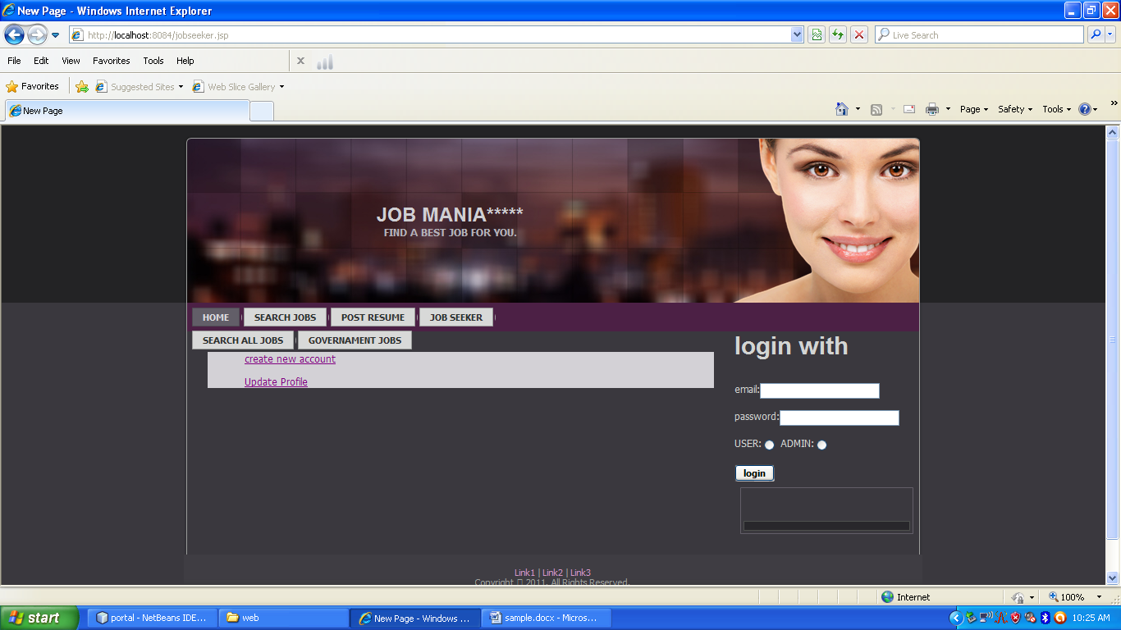
USER LOGIN

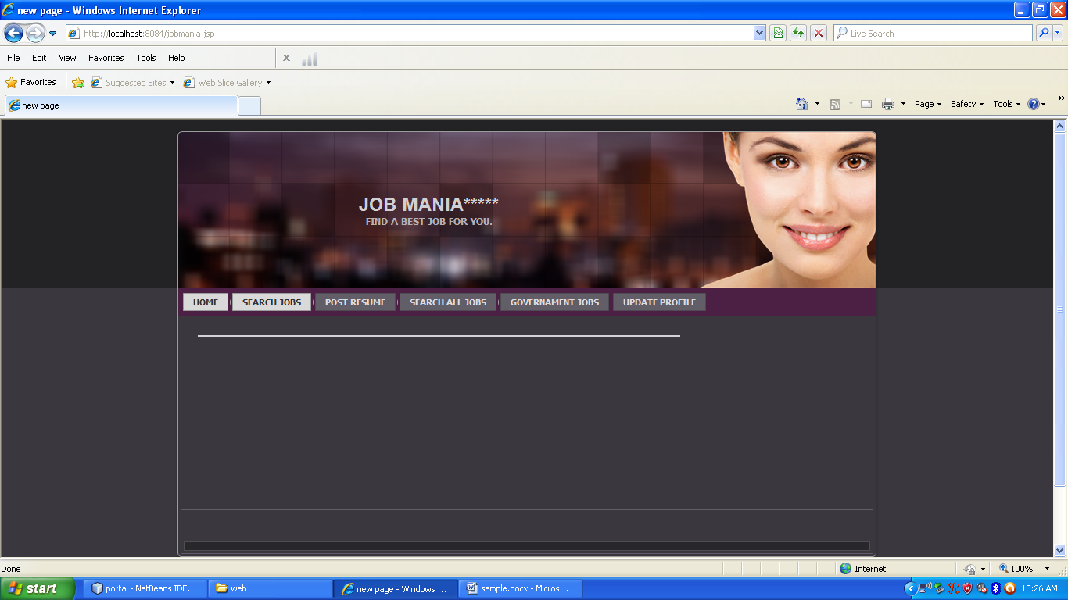
SEARCH JOBS
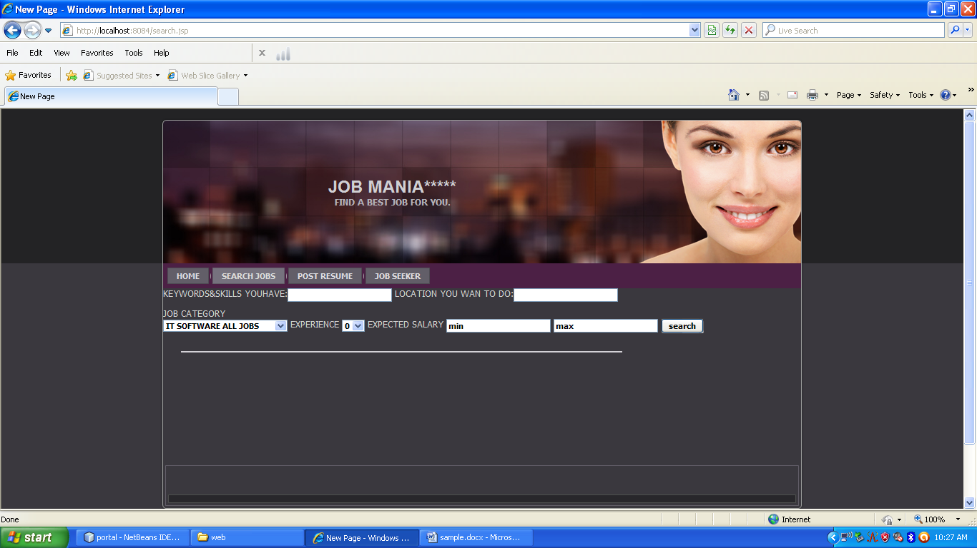

POSTRESUME
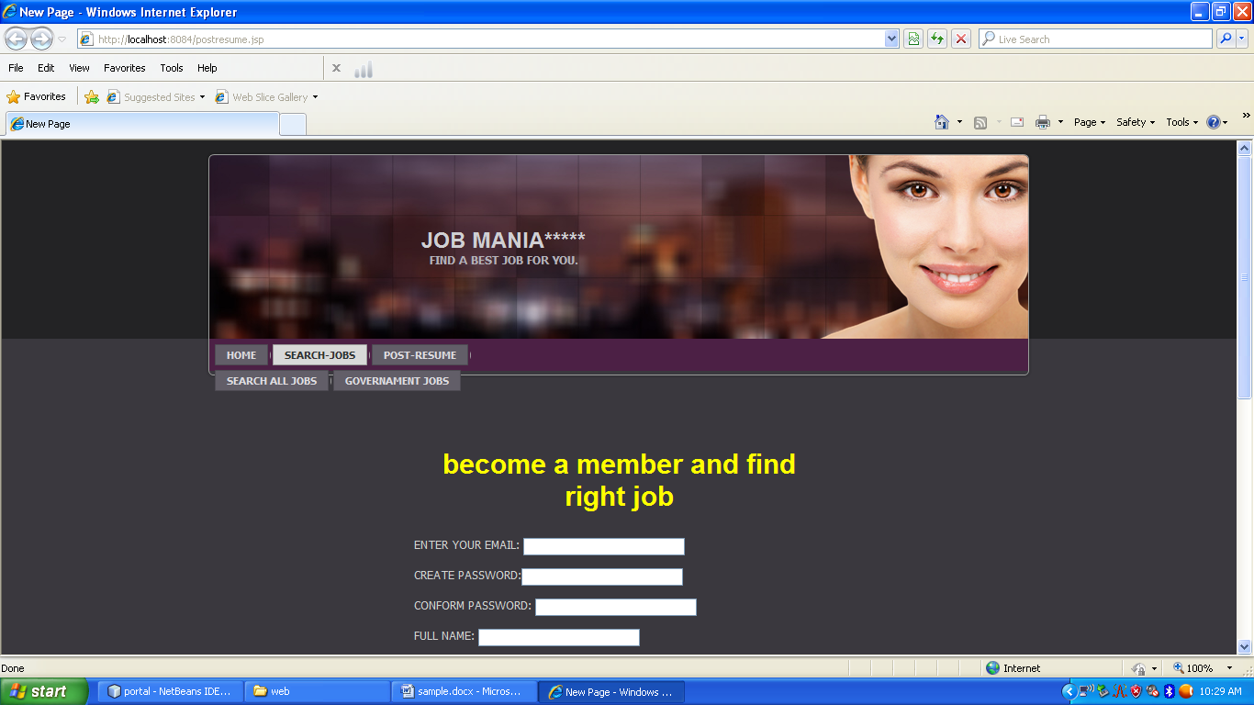

SEARCH ALL JOBS
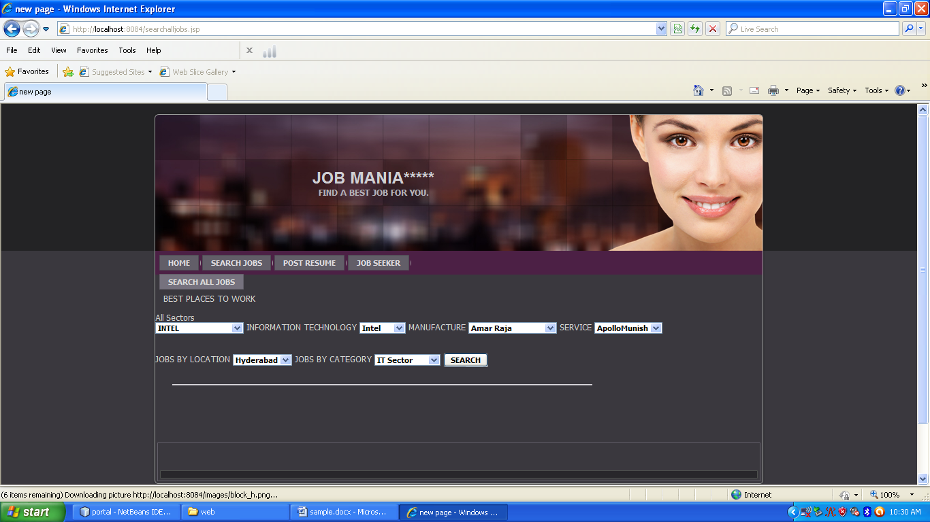
GOVERNAMENT JOBS
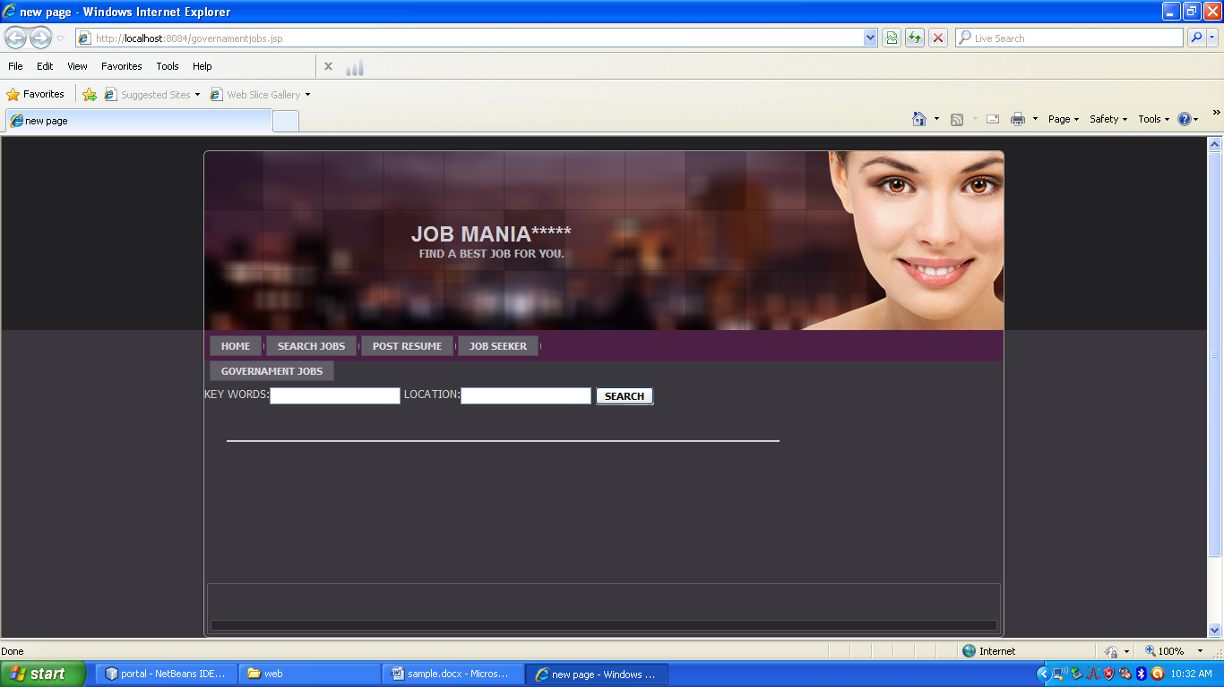
UPDATE
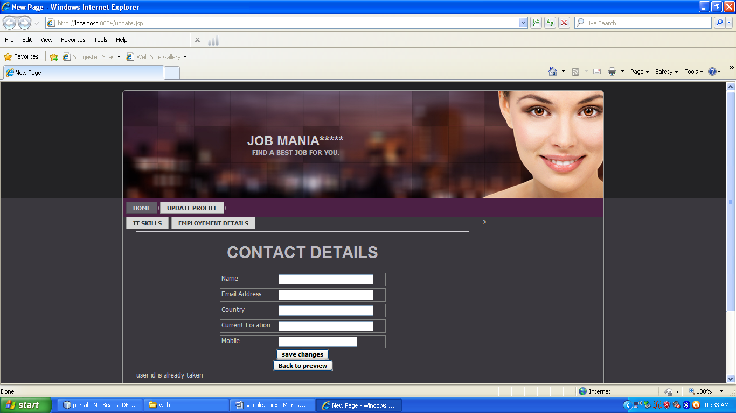

EMPLOYEMENT DETAILS
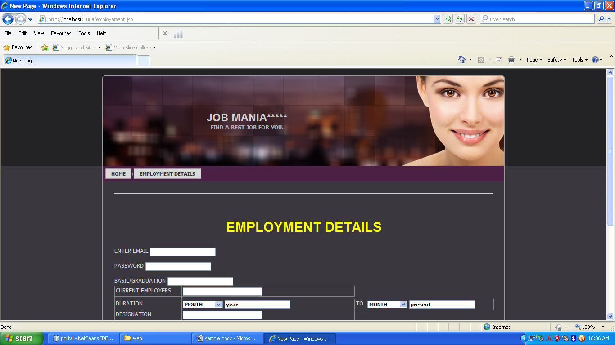

ADMIN LOGIN
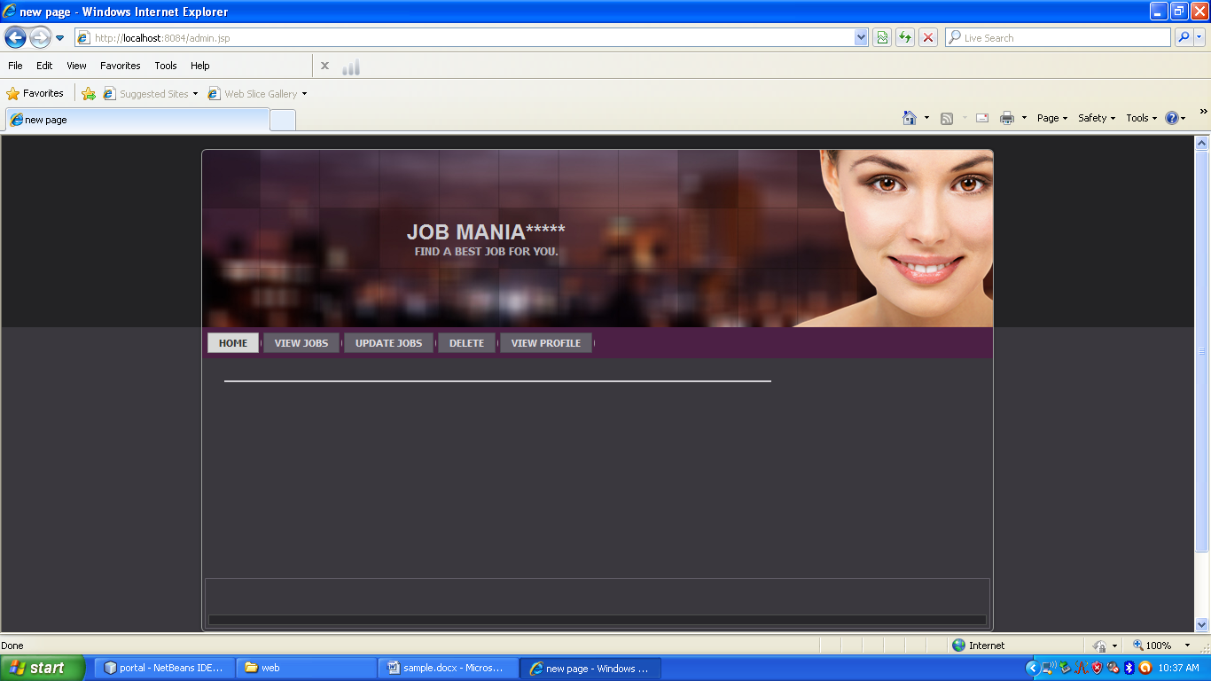
UPDATE PROFILE
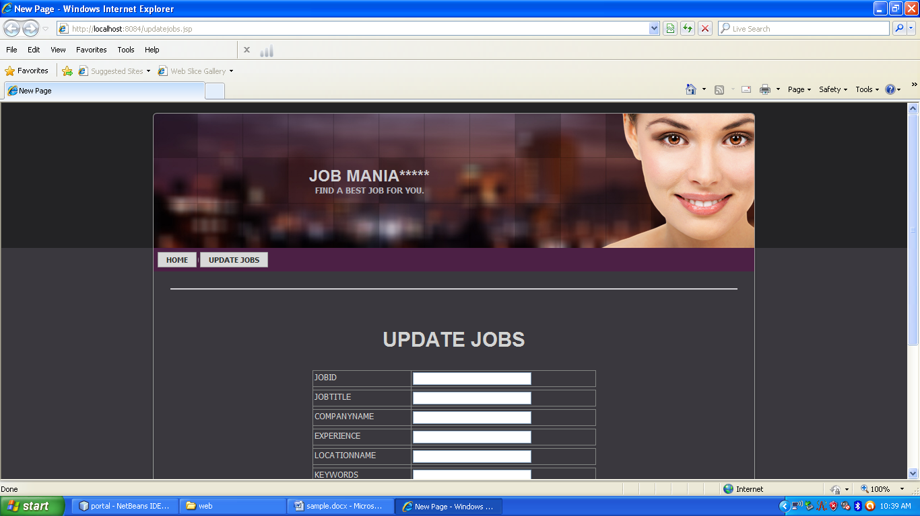

CONCLUSION

8. CONCLUSION

We have proposed and built a comprehensive credential system called Nymble, which can be used to add a layer of accountability to any publicly known anonymizing network. Servers can blacklist misbehaving users while maintaining their privacy, and we show how these properties can be attained in a way that is practical, efficient, and sensitive to the needs of both users and services.
We hope that our work will increase the mainstream acceptance of anonymizing networks such as Tor, which has, thus far, been completely blocked by several services because of users who abuse their anonymity.
.

BIBLIOGRAPHY

9. BIBLIOGRAPHY

Text books Referred:

JSP : Java Server Pages by Peckowsky
The Complete Reference by Phil Hanna
Java Server Pages by Barry Burd
Professional JSP by Simon Brown

JAVA : Java Complete Reference by Patrick Naughton
Concurrent Programming in java: Design
Principles and patterns by Doug Lea

HTML : HTML Black Book by Steven Holzner
HTML and Dynamic HTML by Teri Kieffer

UML : Unified Modeling Language by Iyar Jacobson, Ram Baugh, Grady Booch
Applying Use Case Driven Object Modeling with
UML by Doug Rosenberg, Kendall Scott
MYSQL : A Gide to MY SQL by phillip J .Pratt
And Mary Z Last

Sites Referred:

www.roseindia.net/jsp/jsp.htm
www.w3schools.com
www.jsptut.com
www.htmlref.com

